UNIVERSITY OF ENGINEERING AND TECHNOLOGY
PESHAWAR, PAKISTAN
Main Campus
DATA STRUCTURES
Lab 03 Assignment
Submitted By
Name: ANAS KHAN
Registration No: Bf25pwcs1691
Semester: 2nd Semester, BS Computer Science
Section: B
Submission Date: 30-09-2026
Submitted To: Sir Mudasir
DEPARTMENT OF COMPUTER SCIENCE
UNIVERSITY OF ENGINEERING AND TECHNOLOGY, PESHAWAR, PAKISTAN

Exercises 1: Memory Foundations
Exercises 1
Task 1:

Create one global integer and two local integers. Print their values and addresses. Add comments explaining scope and lifetime.

Code:
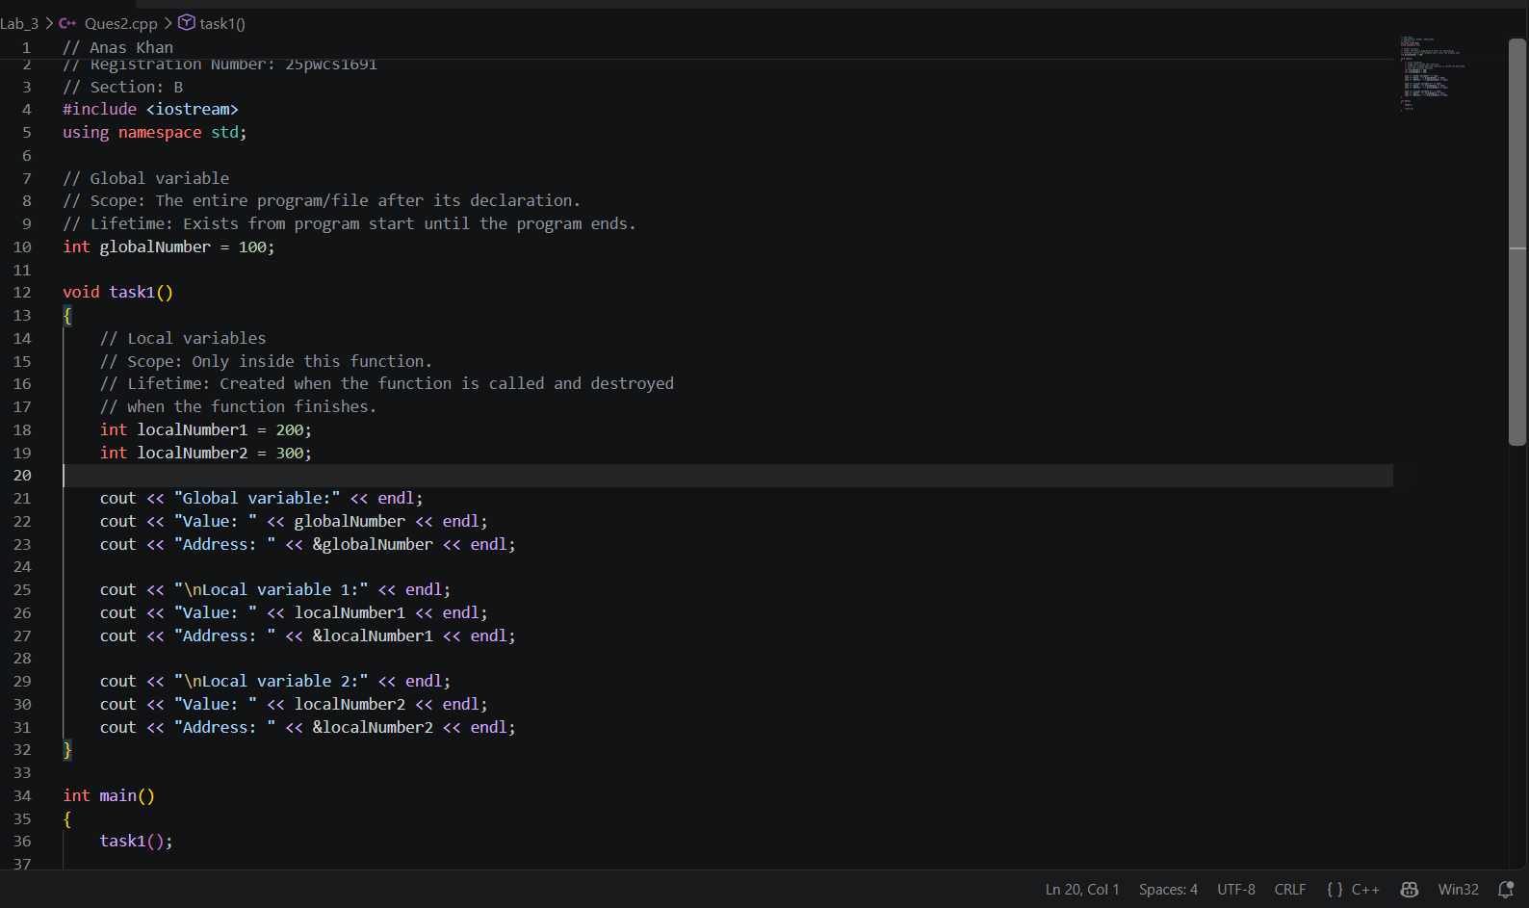

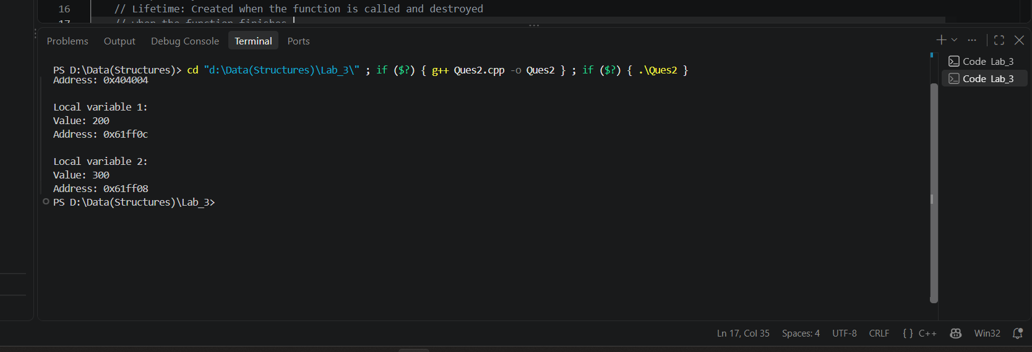
Output:
Task 2:

Declare a fixed array of five integers and a dynamic array of five integers. Print the address of every element in both arrays.

Code:

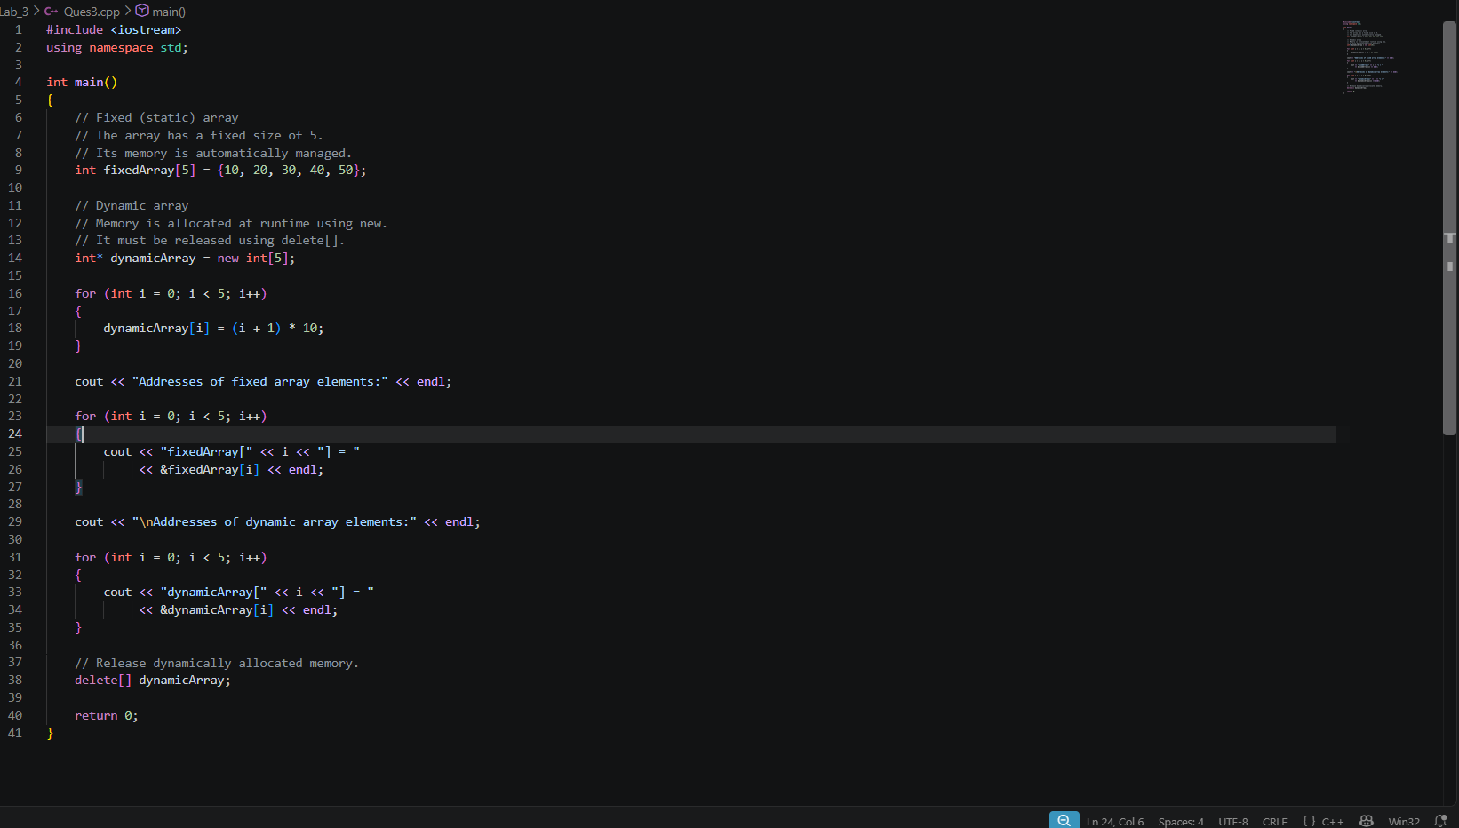

Output:

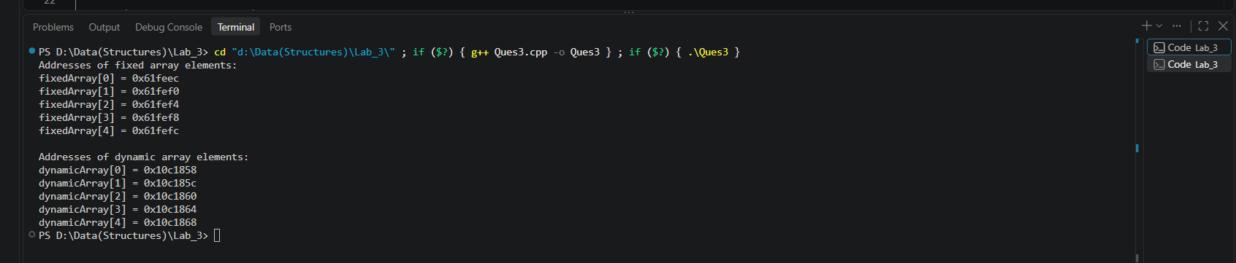

Task 3:

Write a function with a local variable. Call the function three times and print the local variable address each time. Record what you observe.

Code:

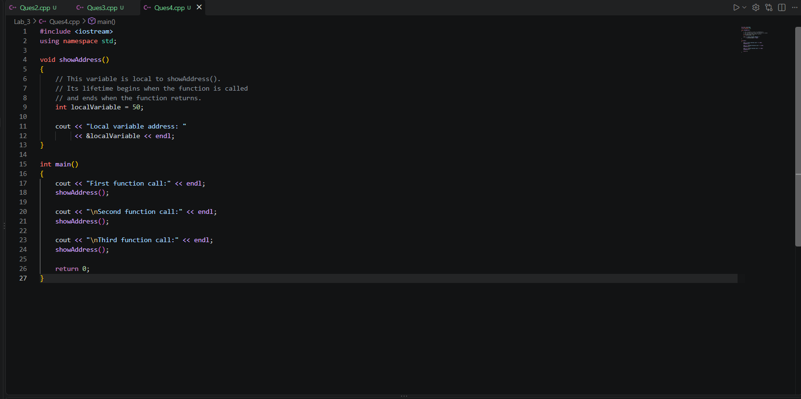

Output:

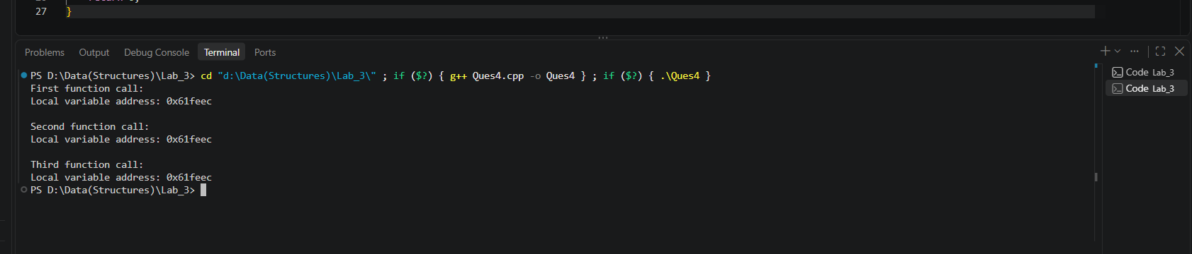

Task 4:
Create a dynamic array and intentionally comment out delete [] for one test run. Explain why this is bad practice even if the operating system eventually reclaims memory after the process exits.
Code:

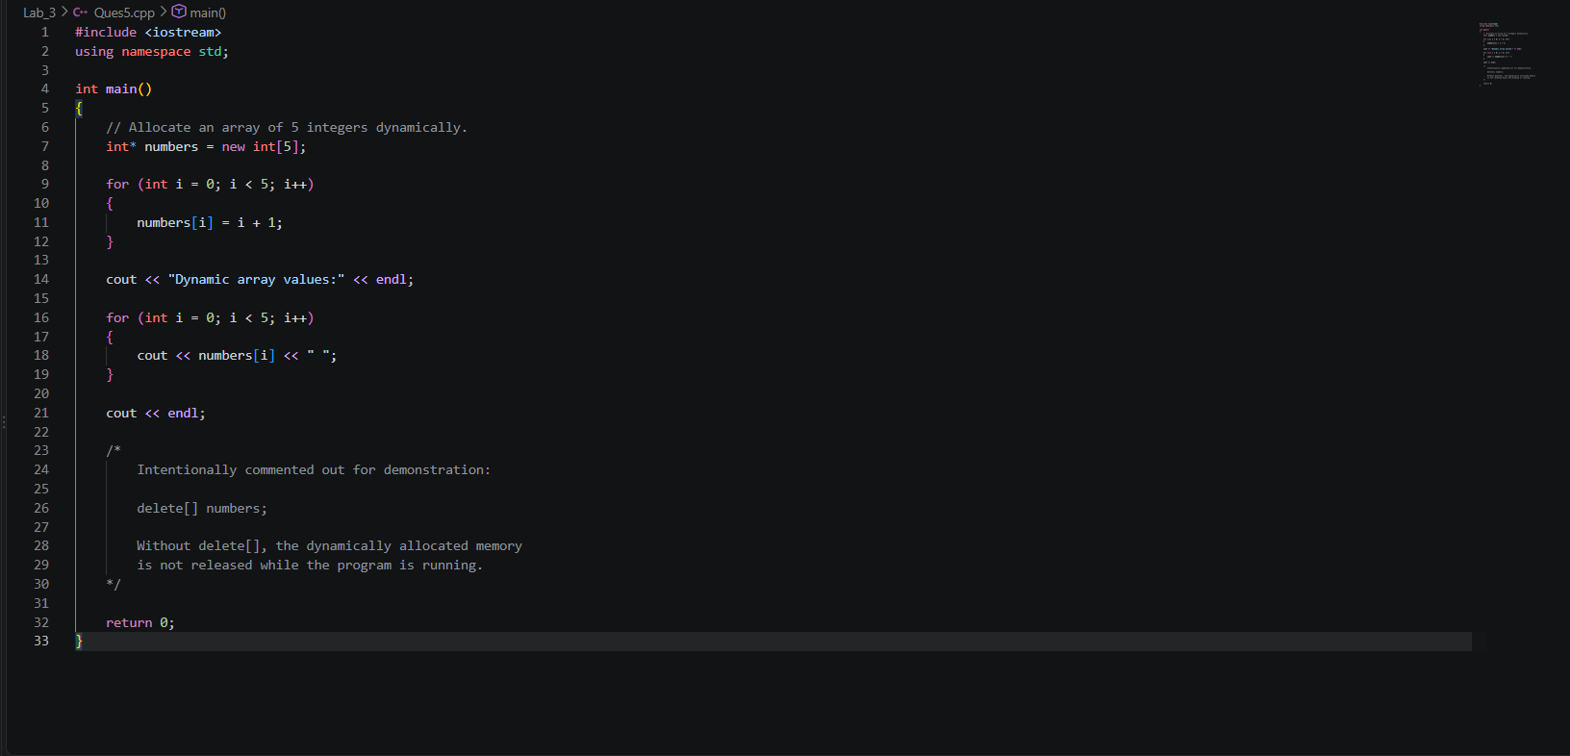

Output:

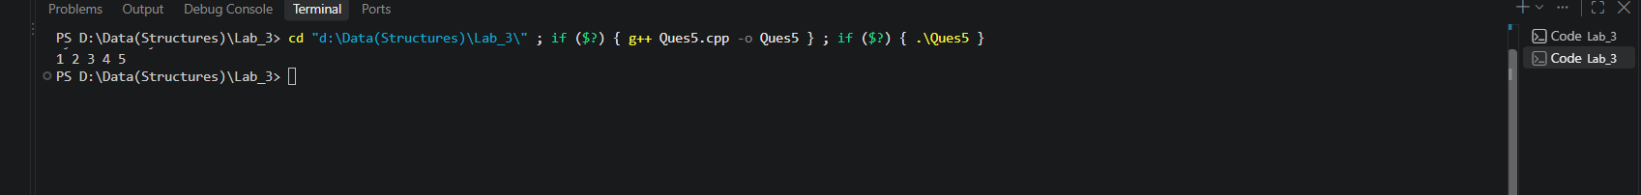Task 5:

Write a short paragraph comparing scope, lifetime, and storage for global variables, local variables, fixed arrays, and dynamic arrays.

Explanation:
Global variables have program-wide scope after their declaration and remain alive for the entire duration of the program. They are stored in static storage and are created before main() begins. Local variables have block or function scope and normally use automatic storage, meaning they are created when execution reaches their declaration and destroyed when their block or function ends. A fixed array declared locally is also an automatic object and stores all of its elements together in its allocated storage, while a global fixed array has static storage duration. A dynamic array is different because its memory is allocated from the free store (heap) at runtime using new[]; the pointer used to access it may be local, but the dynamically allocated array remains alive until delete[] is used. Thus, scope describes where a variable can be accessed, lifetime describes how long it exists, and storage describes where/how its memory is managed.
Exercises 2
Task 1:

Ask the user for n, create a dynamic array of n integers, and display the sum and average.

Code:

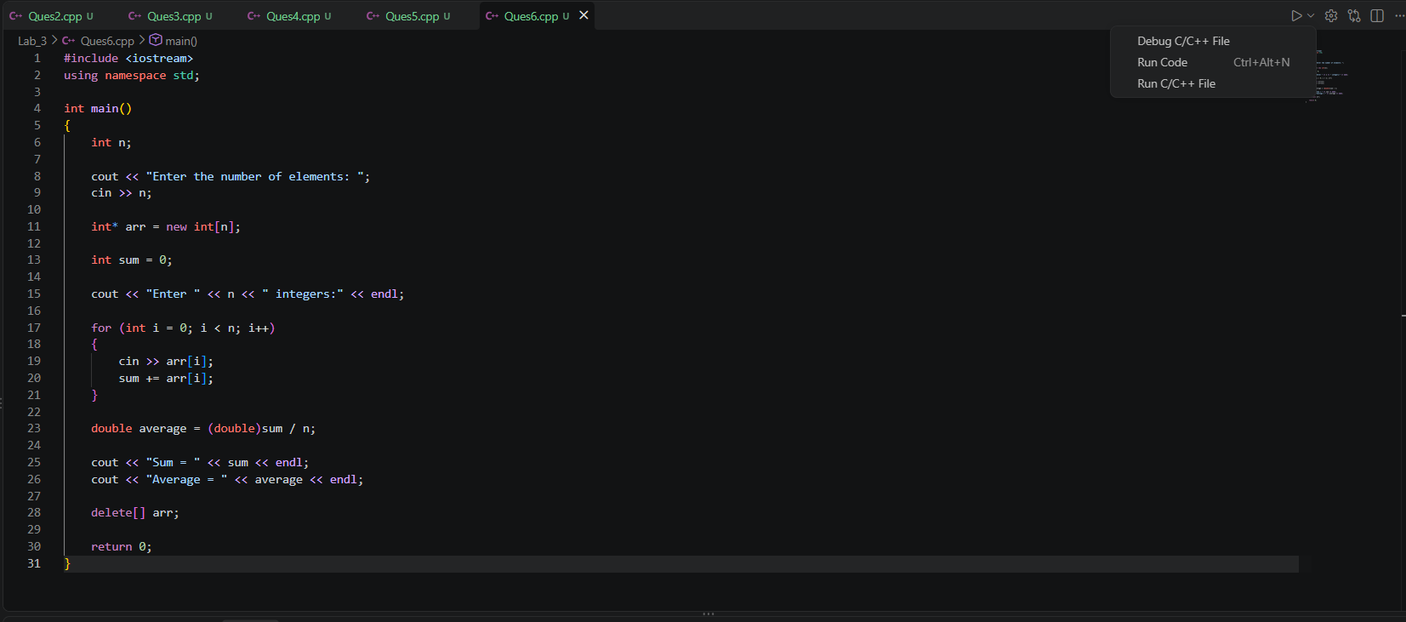

Output:

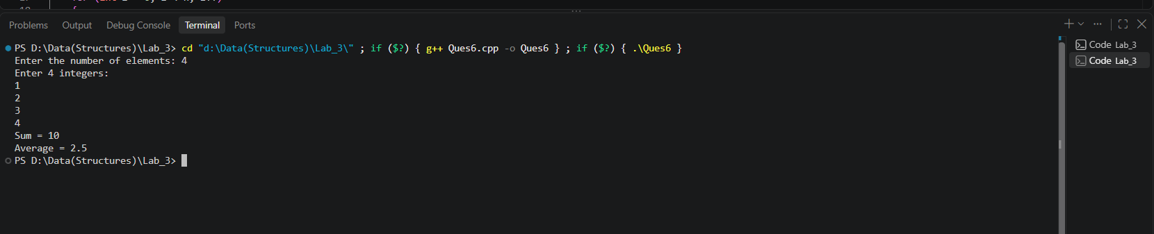

Task 2:

Create a dynamic array and find the maximum and minimum values without using STL algorithms.

Code:

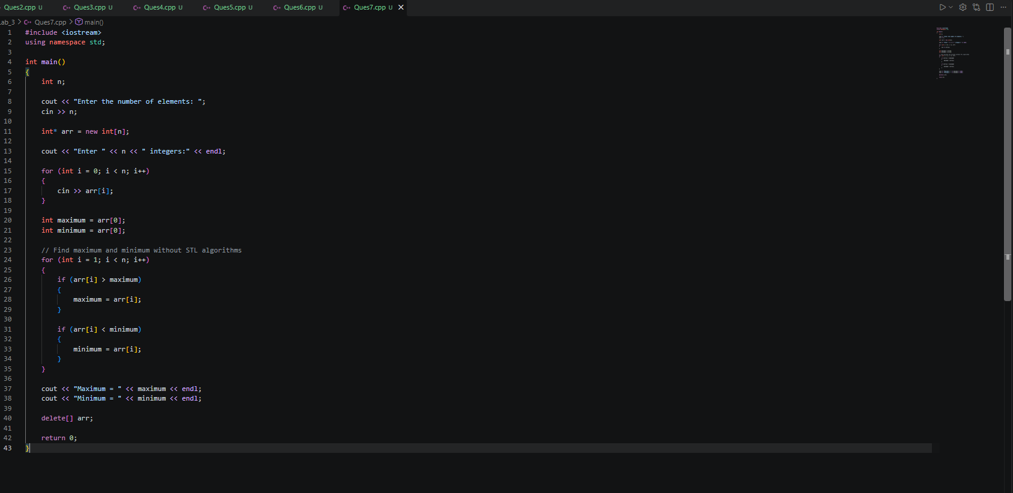

Output:

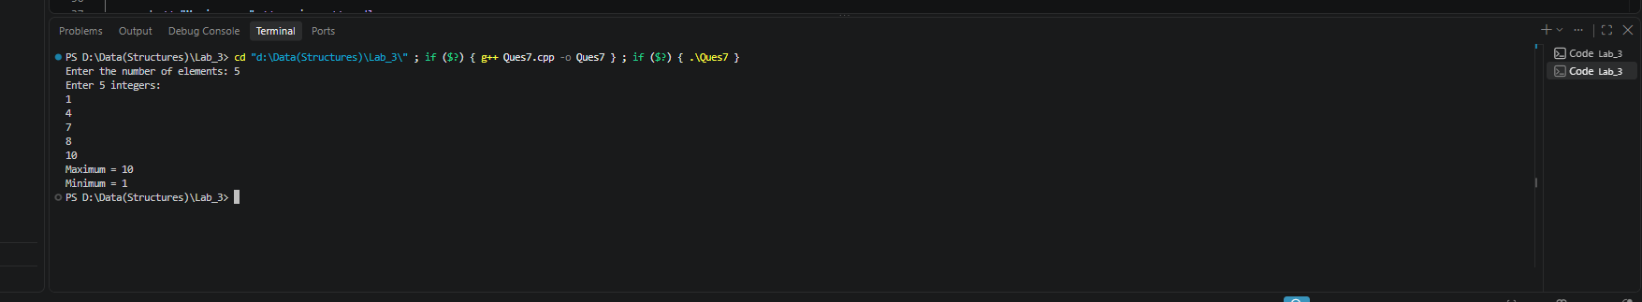

Task 3:

Reverse a dynamic array in place using two indices (left and right).

Code:

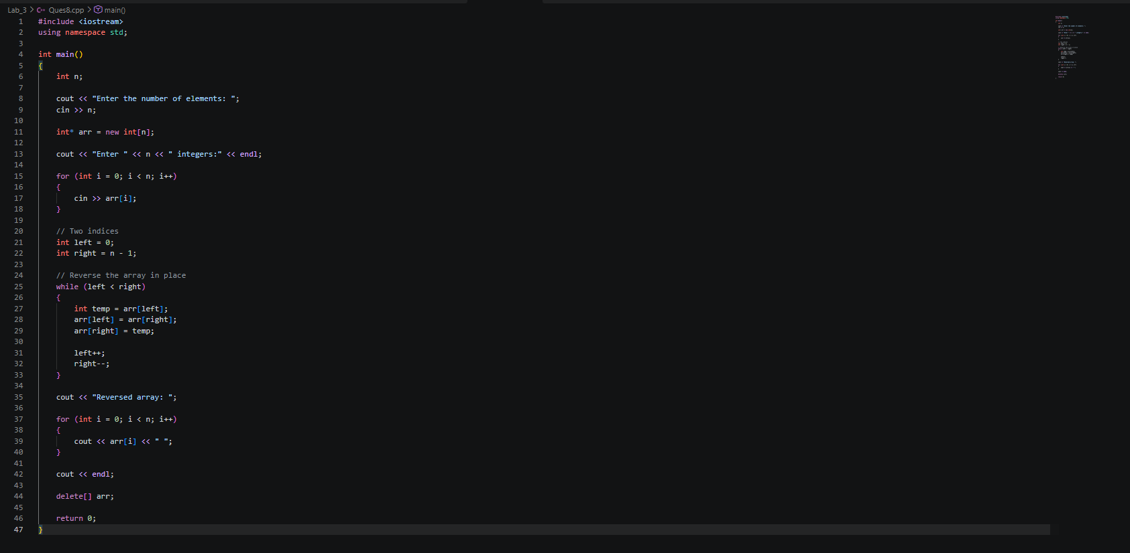

Output:

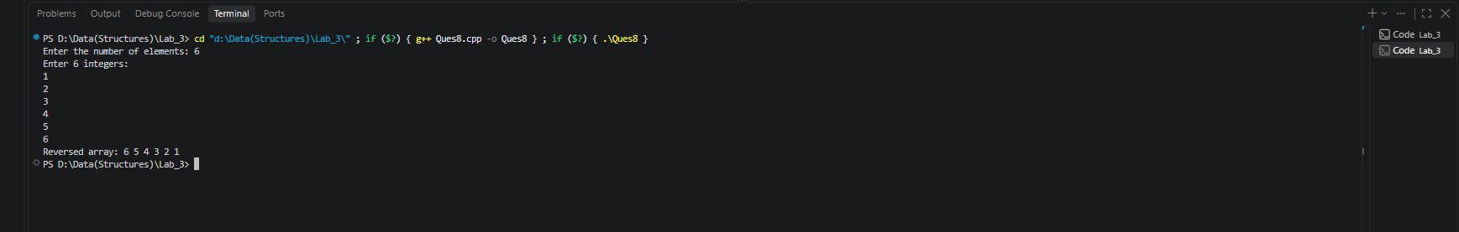

Task 4:

Create an array of n student marks. Count how many marks are &gt;= 50 and how many are &lt; 50.

Code:

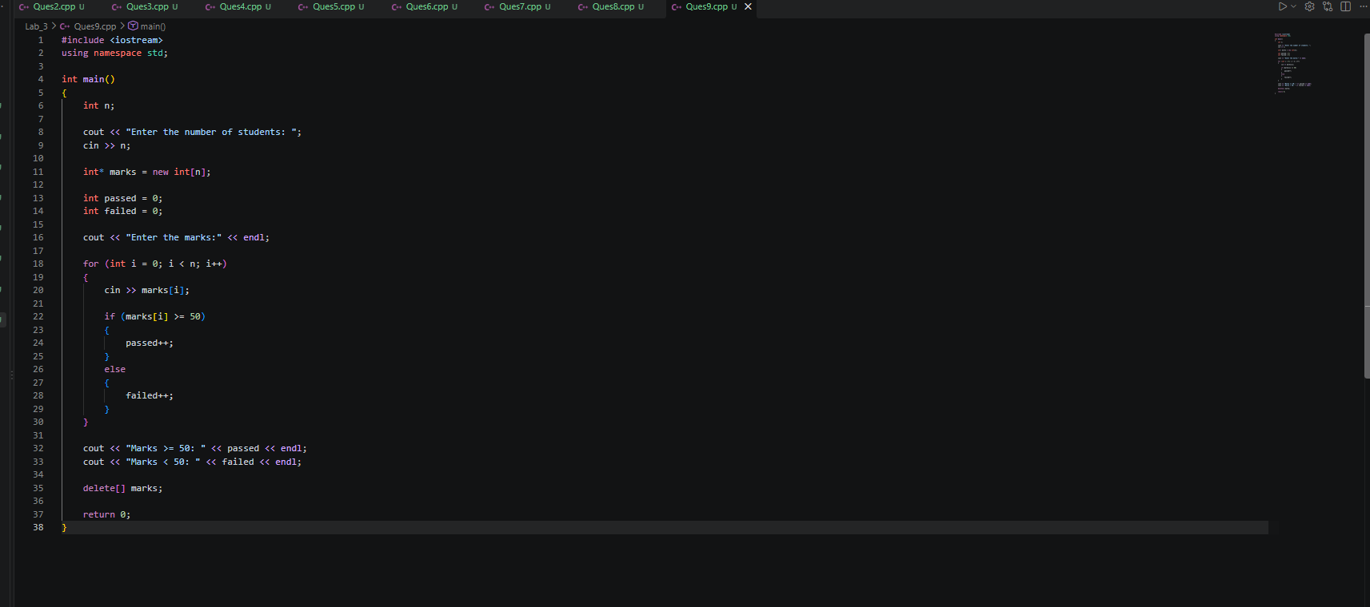

Output:

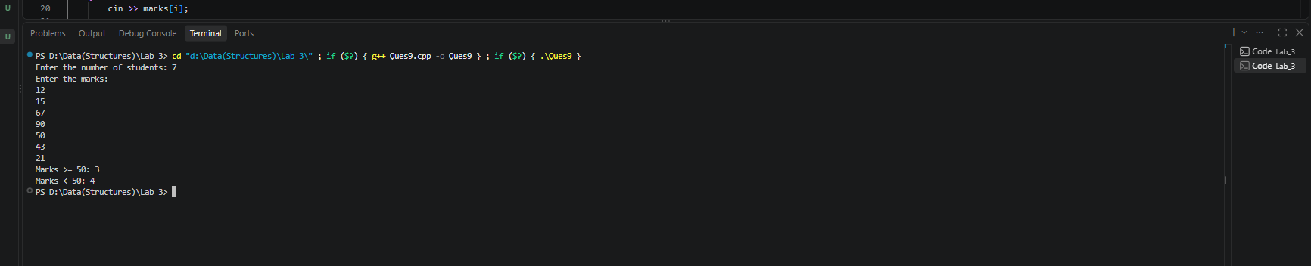

Task 5:

Expand a dynamic array from n elements to n+3 elements while preserving the original values.

Code:

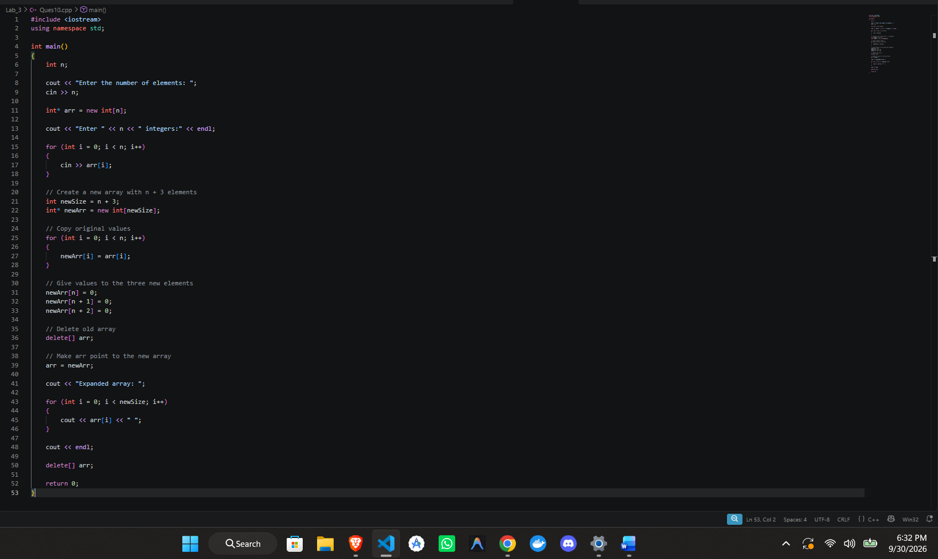

Output:

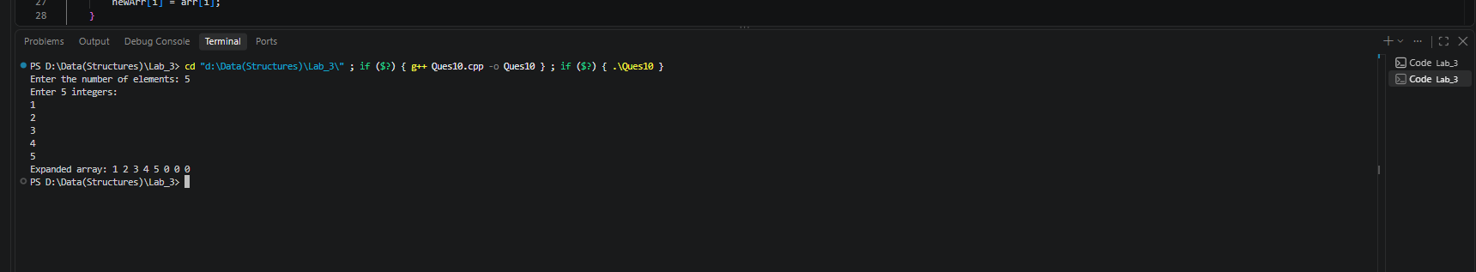

Task 6:

Write a function int* createArray(int n) that returns a newly allocated array, and another function void destroyArray(int*&amp; p) that deletes it and sets the pointer to nullptr.
Code:

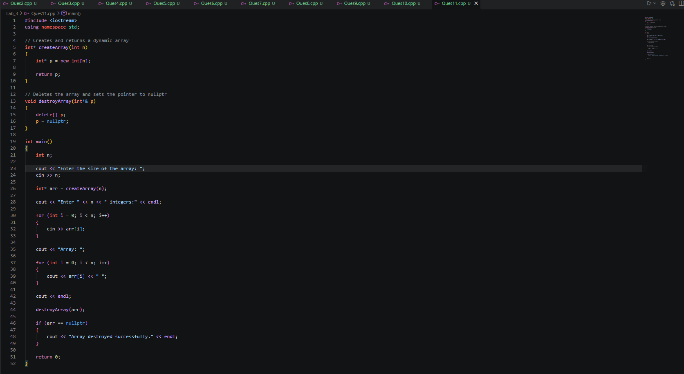

Output:

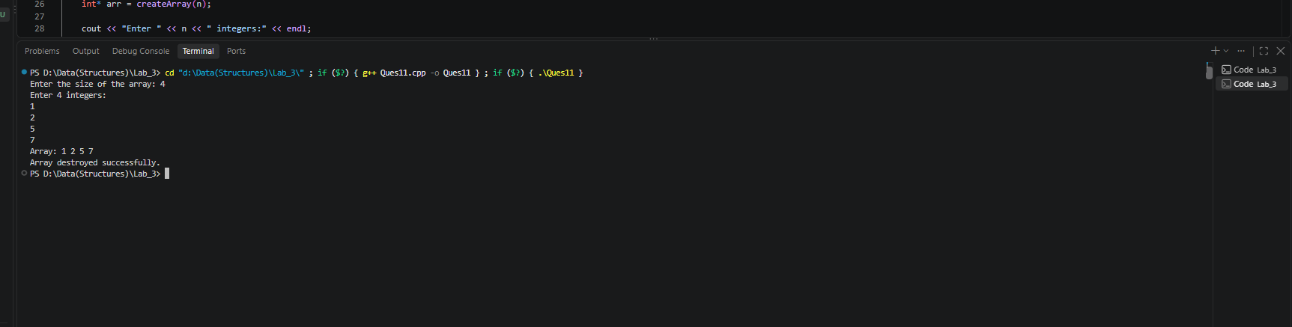

Task 7:

Challenge: Implement a small “score bag” with capacity and used-size variables. When used-size reaches capacity, allocate double capacity and copy the elements.
Code:

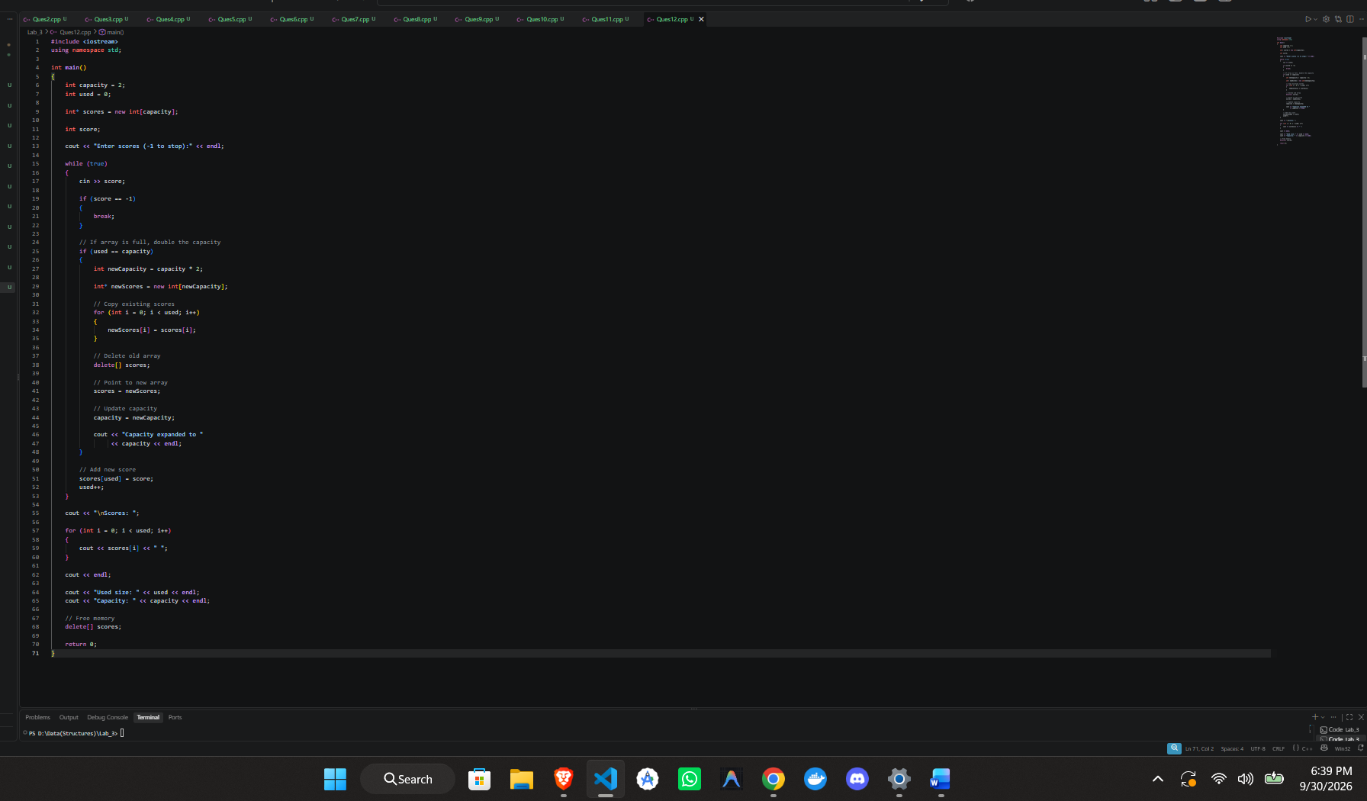
Output:

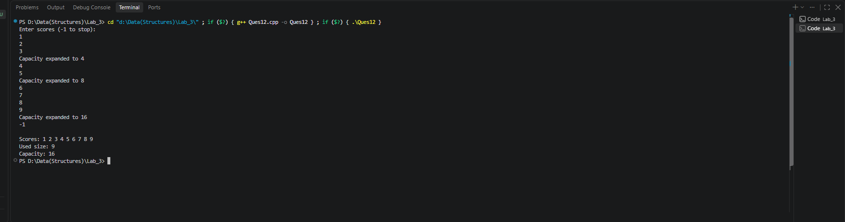

Exercises 3
Task 1:

Search for a student roll number in an unsorted integer array.

Code:

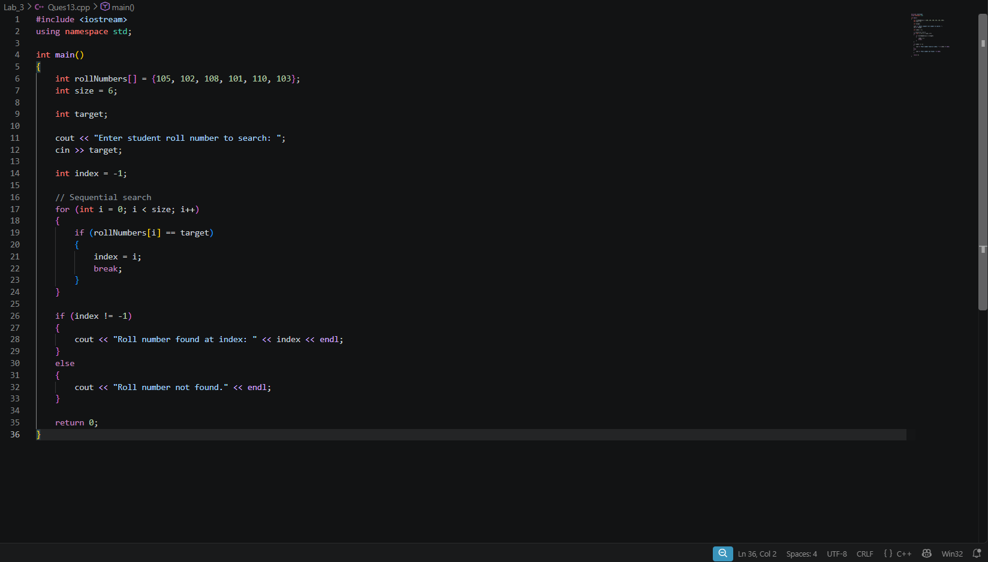

Output:

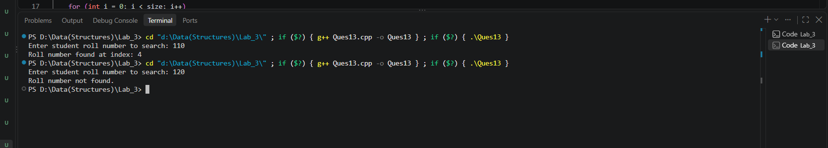

Task 2:

Modify linear search to count all occurrences of a target value instead of stopping at the first match.

Code:

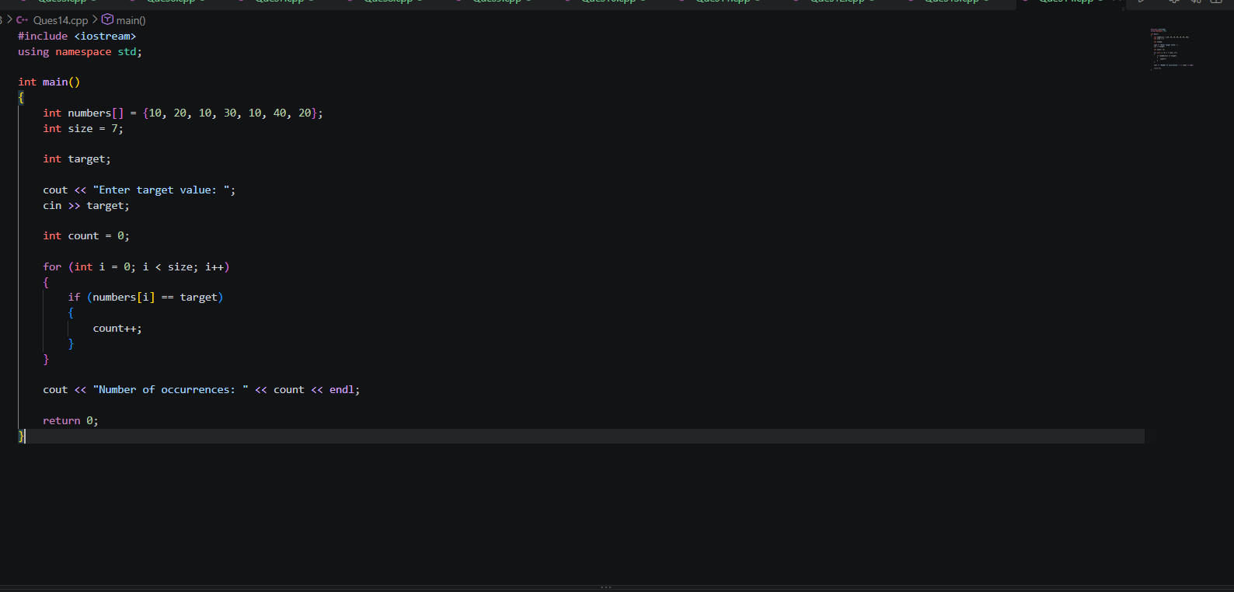

Output:

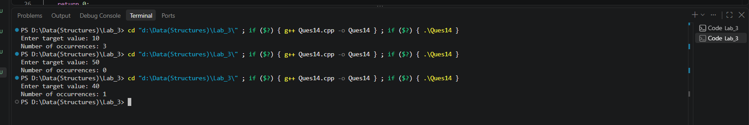

Task 3:

Return the index of the last occurrence of a target.

Code:

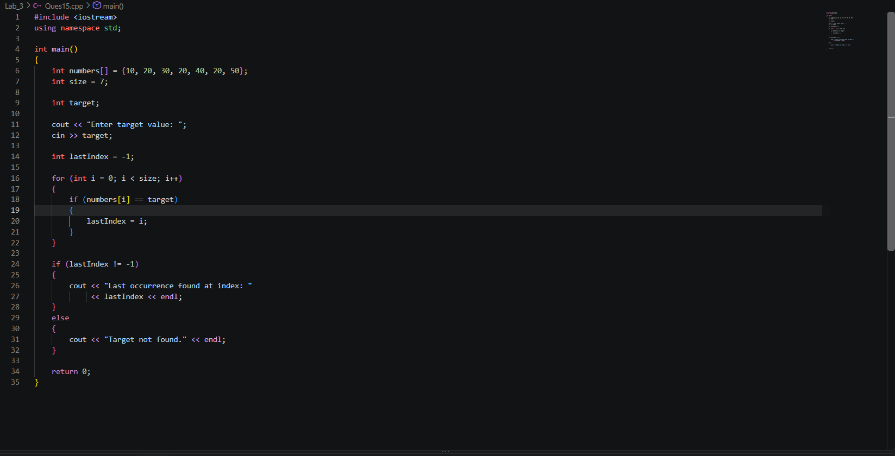

Output:

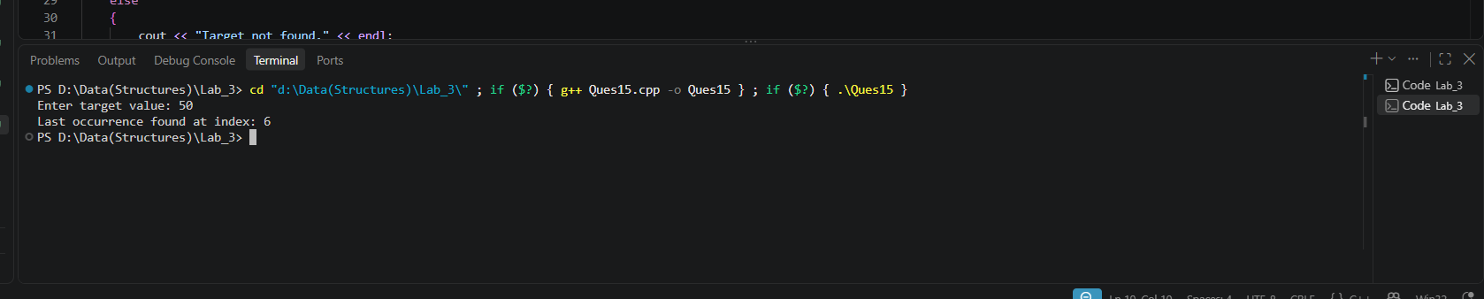

Task 4:

Perform linear search on a dynamic array created from user input.

Code:

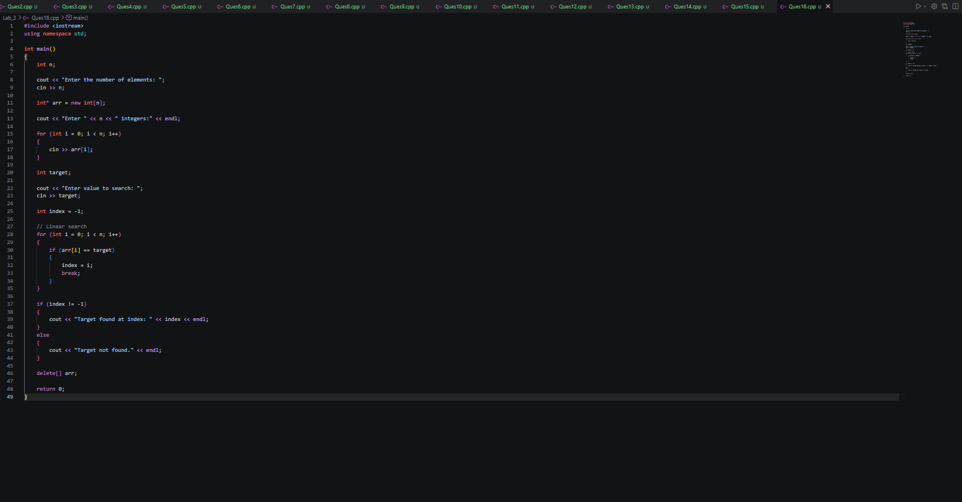

Output:

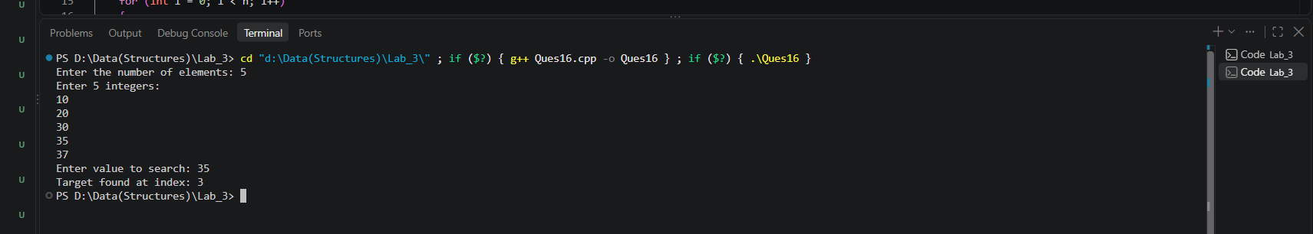

Task 5:

Count the number of comparisons performed before the target is found.

Code:

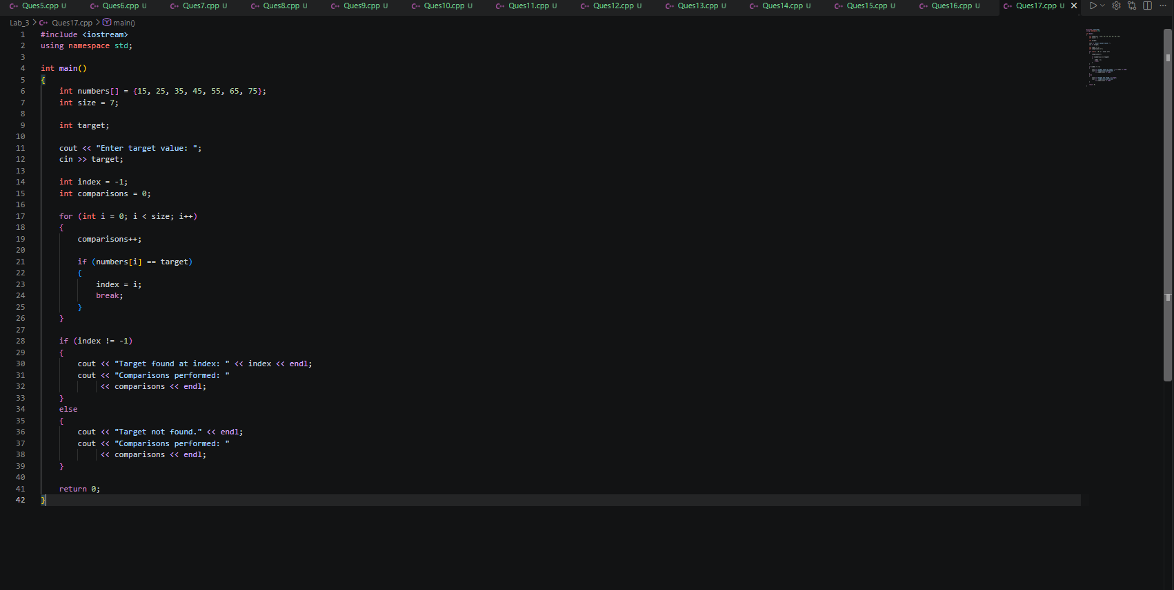
Output:

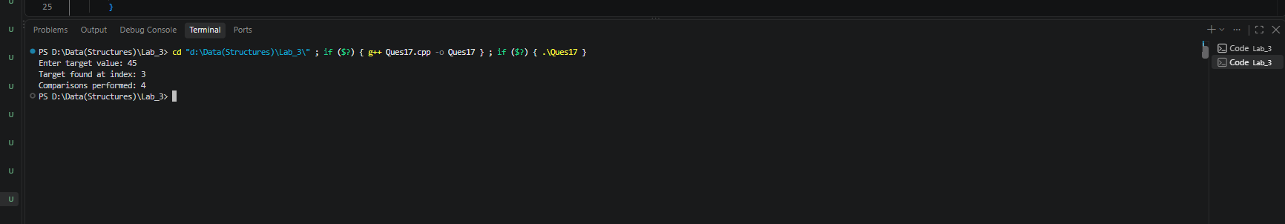

Task 6:

Search for a target inside a 2D matrix and print the row and column where it is found.

Code:

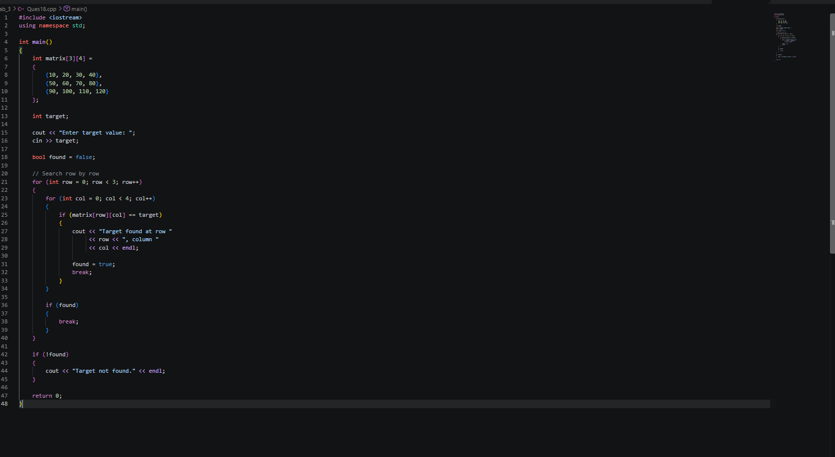

Output:

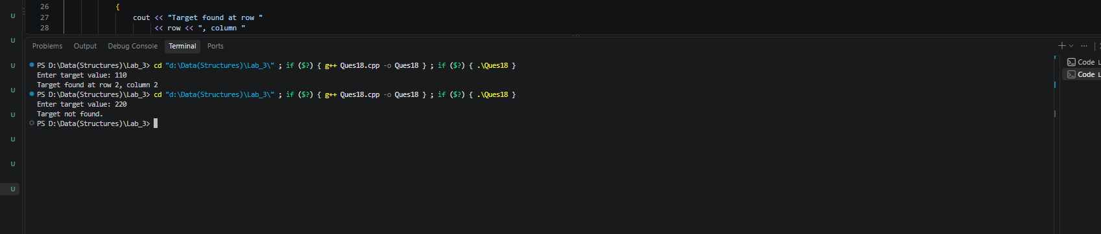

Task 7:

Challenge: Search a list of marks and return all indices where the target mark occurs.

Code:

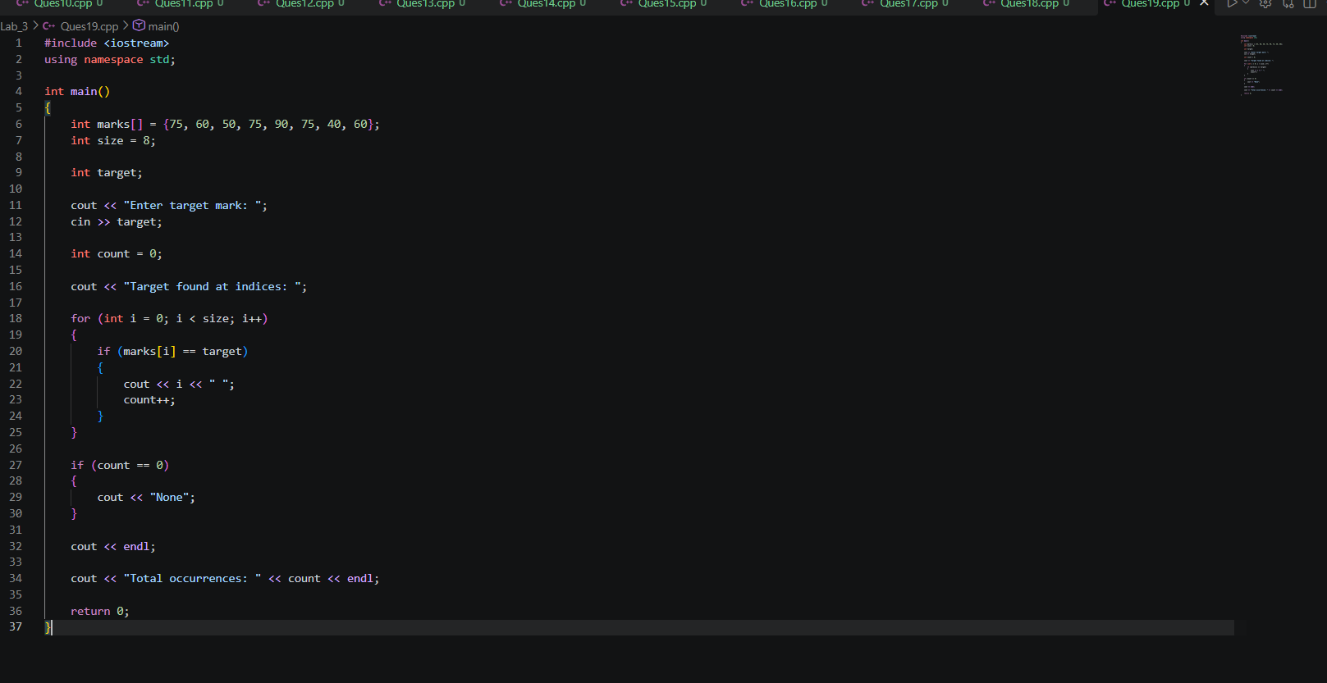

Output:

